Room B
BQ1 Enterovesicular Fistula in Crohn’s
Stem: 31 y/o male presents with dysuria and pneumaturia for the last 3 weeks without other changes in his bowel habits.
PE: vital signs and physical exam are grossly normal.
PMH: Crohn’s Disease on Mesalamine (Pentasa).
PSH: None.
Labs: CBC, CMP with normal values. Urine analysis and urine cultures showed growth of enteric flora.
Any further infomrations you want?
- Colonoscopy: Less than 1 year ago, he thought it showed good control of his disease.
- CT scan Abdomen / pelvis? – What kind of contrast? Rectal / Oral (Consider no IV contrast to allow extravasation showing from bowel to bladder) – CT showed air in the bladder.
- MRI (MR Enterography) (best sensitivity for diagnosis): Fistulous connection between dome of the bladder and distal small bowel visualized.
- Cystoscopy: Erythema in the dome of the bladder
- SBFT or barium enemas:(Have a poor prediction for EV-fistulas)
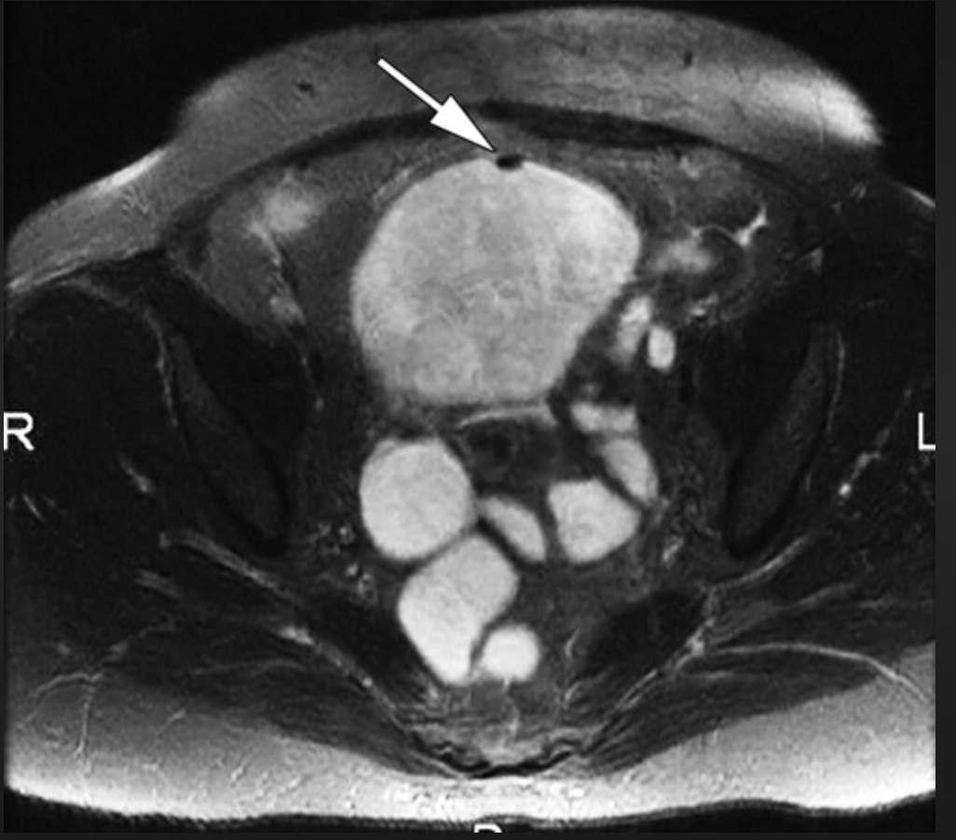
(MR Enterography picture, air in the bladder at fistula site)
Describe what options exist for medical management of Crohn’s and when they are indicated.
- 5-ASA compounds: Induction agent, not very effective long term.
- Steroids: Induction agent for flairs, not to use long term.
- Thiopurines/MTX: Used for maintenance, not in acute flairs.
- Biologics: Infliximab (Remicade)→ adalimumab (Humira) → other options. Used for moderate to severe diseases not responsive to other agents.
What would you like to do now?
- Treat UTI First – Augmentin vs cipro+flagyl.
- Step Up management: continue mesalamine → glucocorticoids → immunomodulators → Biologics
- In this patient, steroids for induction + antibiotics to treat possible infection is a reasonable first approach.
- If symptoms do not improve, consider Anti-TNF agent vs. surgery.
- If surgery is planned, hold off on immunomodulators until post-op period is over.
Scenario: Patient has persistent entero-vesical fistula despite treatment with Remicade. What now? Surgery
- Describe:
1. Can be done MIS or open
2. Place foley catheter
3. Resect fistulizing segment of small bowel with the fistula tract– do not have to do a large bladder resection.
4. Do a limited resection of just involved bowel.
5. Visualize ureters
6. Can inject methylene blue into catheter to visualize bladder defect
7. Repair bladder defect with absorbable suture, 2 layers
8. Leave Foley catheter for 1-2 weeks – can do a cystogram before pulling
Scenario 2: Now your patient is a 75 y/o male with no hx of IBD. He presents with pneumaturia and fecaluria. What is your diagnosis and what do you do differently from before?
- Concern is for colovesical fistula: Diverticular vs Malignancy.
- Colonoscopy: Doesn’t have one before
(Must obtain: Resident must do themselves and describe steps)
- cystoscopy to rule out cancer.
- CT: Sigmoid colon adherent to the bladder, diverticulosis, air in bladder. No abscess.
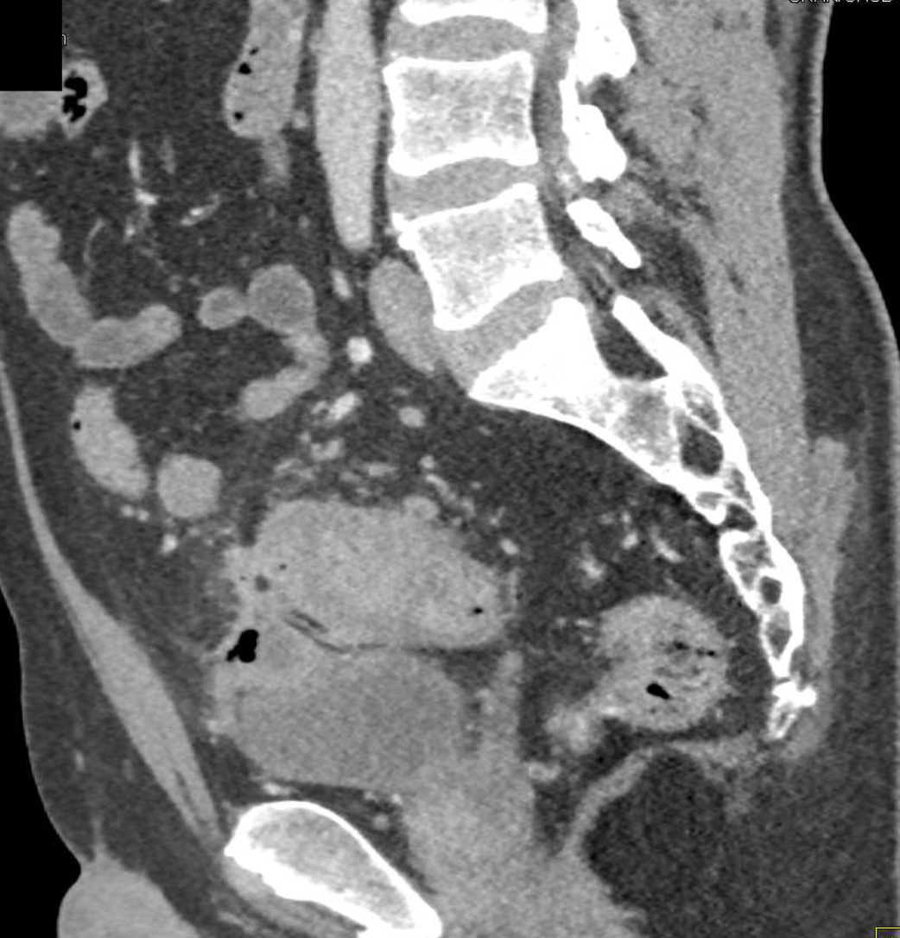

How do you treat? Surgery
- Sigmoidectomy.
(Open / lap / Or Robotic … Lateral to medial or medial to lateral dissection)
- Patient in dorsal lithotomy
- Mobilize the sigmoid colon along white line of Toldt or via medial to lateral approach score the peritoneum along the right side.
- Identify the inferior mesenteric artery.
- Identify left ureter.
- Take down the adhesions of the sigmoid colon to the bladder.
- Resect
- Anastomosis.
- Fill foley with sterile fluid and clamp, to distend the bladder and assess for urine leak: (Usually no leak and no need to repair)
- Leave foley in place for 1-2 weeks, can do cystogram before discontinuing.

Pitfalls:
- Not Performing colonoscopy, themselves.
- Not knowing medical management of Crohn’s disease.

BQ2 Traumatic Pelvic Fracture and Bladder Injury.
Stem: A 22 year-old is on a motorcycle group ride when he crashes his motorcycle on the highway. He is helmeted. He is thrown approximately 30 feet. The patient is found unconscious by emergency medical services (EMS).
He is hypotensive with systolic blood pressure in the 80s. He responds to a 1 L normal saline (NS) fluid bolus by EMS, and systolic blood pressure is now 100 mm Hg.
Upon arrival to the trauma bay, he is awake but confused. He is tachycardic with heart rate in the 140s. Systolic blood pressure is back in the 80s. He is given 2 units of uncrossmatched O positive blood. He is complaining of lower abdominal pain and significant bilateral hip pain.
What would you like to do now?
- ATLS (ABCDE) (Airway, breathing, circulation, disability, exposure).
- Two wide bore 16-18 gauge IV cannulas. Obtain blood for labs (Type and screen / cross match, CBC, CMP, Coags, lactate).
- Secondary Survey:
-Assess pelvic ring instability: How? applying gentle pressure from the lateral aspect of each iliac wing with both hands.
-Lower extremity abnormal rotation.
Blood at urethral meatus.
DRE: Digital Rectal Exam.
- Chest and pelvic films.
- FAST.
The patient in the scenario undergoes a chest x-ray with no acute findings Pelvis x-ray shows:
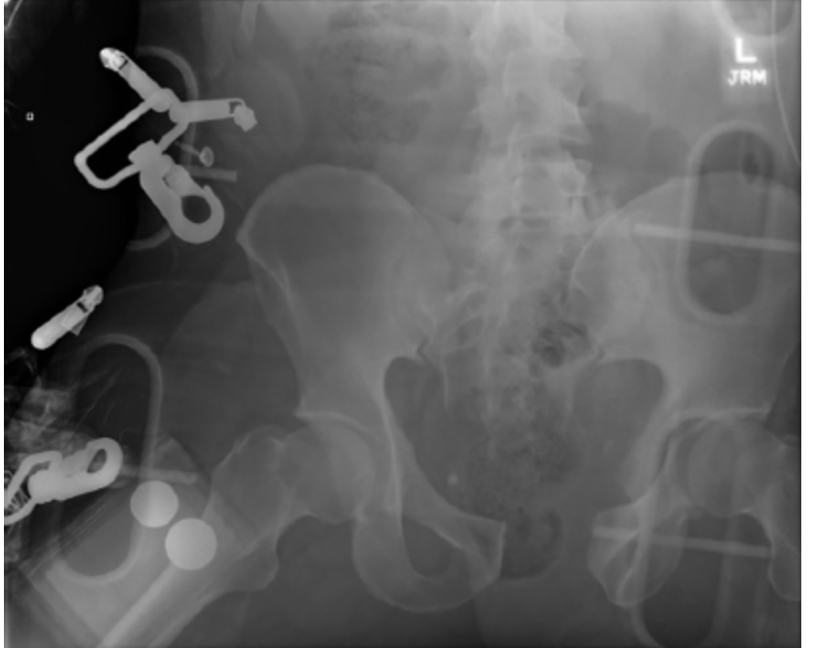
Widening of the pubic symphysis. There is diastasis of the right sacroiliac (SI) joint.
Now what? Pelvic binder
- The patient was resuscitated according to ATLS guidelines. He stabilized after transfusion of 2 units of blood in the trauma bay. A pelvic binder was placed. FAST was positive for fluid in the pelvis.
Now what? CT imaging.
- CT imaging.
  - A large volume of contrast-enhanced urine was identified within the peritoneum on delayed images. (To the examiner: consistent with urine extravasation and not contrast from pelvic vasculature)
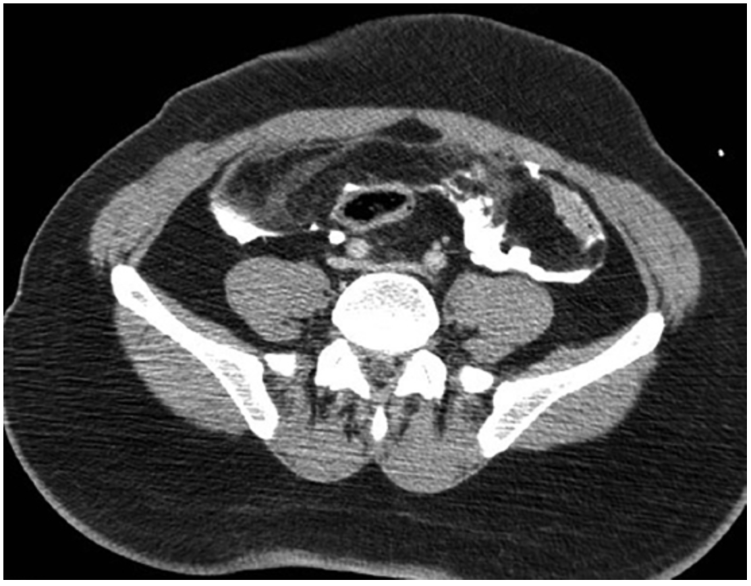
- An “open-book” pelvic fracture. You get 3-D reconstruction image.
- 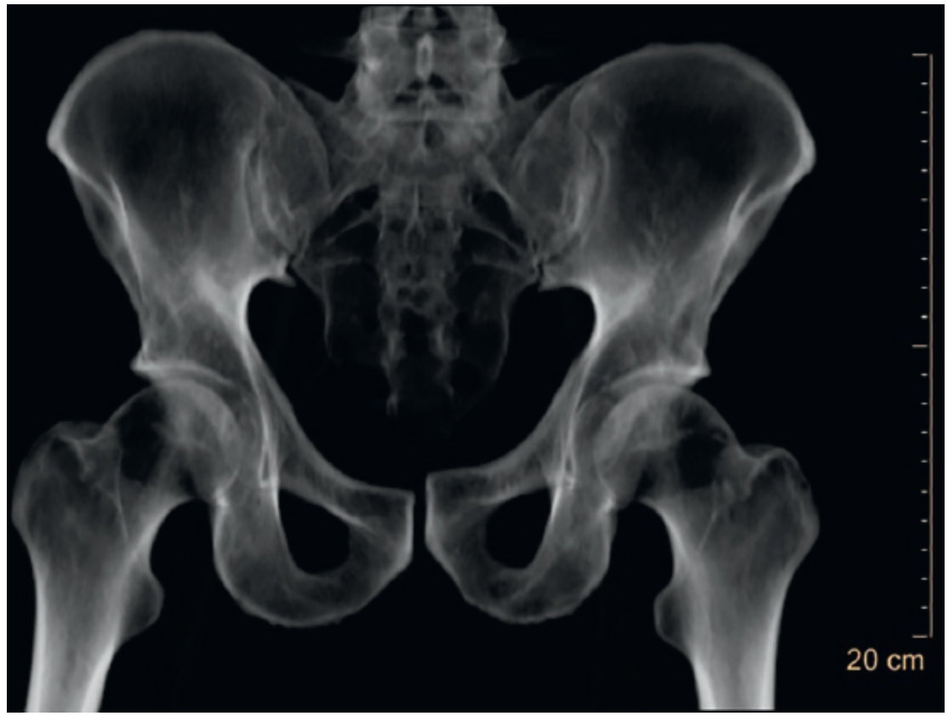

What is your diagnosis and what is your next step?
- Intraperitoneal bladder rupture and open book pelvic fracture.
- Ex. Lap: Limited incision as extending the incision below the semilunar line may lead to further hemorrhage by increasing anterior extension of a pelvic hematoma.
- Bladder repair. How?
  - Assess trigone and ureters.
  - Two layers.
  - Test repair by instilling 200 mL of normal saline into the bladder, clamp the foley and assess for leak.
  - Leave Foley.
- Ortho were involved and the patient underwent open reduction and internal fixation of pelvic fracture with a plate and closed treatment of right SI joint diastasis.
Can you describe the classification of pelvic fractures?
- five categories:
  - lateral compression (grades I to III)
  - Anterior compression (grades I to III)
  - Vertical shear
  - Combined mechanism
  - Acetabular fractures

Scenario: Same patient, CT showed contrast extravasation in the pelvis and the patient remained hemodynamically stable after blood transfusion. Then what?
Angioembolization
Scenario: Same patient, he was hemodynamically stabilized with blood transfusion and CT showed contrast extravasation in the pelvis. After CT, patient became again hypotensive. You proceeded to the OR for ex.lap. Describe?
  - Ex. Lap: Limited incision, stay above the semilunar line. (Extending the incision below the semilunar line may lead to further hemorrhage by increasing anterior extension of pelvic hematoma) Tightly packing the pelvis intraperitoneal.
  - Preperitoneal packing with separate lower incision.
  - Temporary abdominal closure.
  - Postoperatively, the patient may need to be managed with angiography and embolization if there is continued hemorrhage.
  - Once stabilized, the patient can be returned to the operating room for re-exploration. Stabilization of the pelvis fracture, either internal or external, may be considered in conjunction with orthopedics.

BQ3 Liver Abscess
Stem: You are called to the ED to see a 78 y man who presents with 3 day history of fevers and chills, sweats and feeling poorly. He reports RUQ abdominal pain and some nausea but no emesis. He is otherwise healthy.
Vitals: T=99.9 degrees, BP=100/60, HR 110, and RR of 20.
Physical exam: Tender to palpation in the right upper quadrant without guarding or peritoneal signs.
Labs: WBC of 18K, LFTs slightly elevated, otherwise rest of labs normal.
PMH/PSH: Diverticulitis. Colonoscopy 1 year ago with diverticulosis
What Studies you would like to obtain to help you narrow the differential diagnosis?
- RUQ US: 7 cm fluid mass in the rightl lobe of the liver
- CT Abd/Pelvis : 7 cm fluid, with hyperenhancing rim and few air bubbles within it.
Based on these findings what is your differential diagnosis?
- Pyogenic liver abscess.
- Amoebic liver abscess.
- Simple cyst.
How would you manage it?
- IV access: Fluid resuscitation.
- Broad spectrum Abx to cover GI Flora.
- Look for primary source if suspecting pyogenic abscess.
- Serologic testing if concerned about amoebic abscess.
- IR drainage.

Scenario 1: CT showed 3cm abscess not easily accessible by IR?
- long term antibiotics alone, in a stable patient may be reasonable. If gets worse, may need OR instead of IR.
Scenario 2: Patient presents in shock, hemodynamically stabilizes with resuscitation and able to proceed to CT. Findings included Intraperitoneal rupture/peritonitis? IR not available immediately and patient becomes hypotensive again.
- Patient should proceed to OR for operative debridement/drainage.
- Laparoscopic approach is preferred over open approach.
- Intraoperative US should be done to confirm complete drainage and not to miss another abscess).
Scenario 3: Patient presents with 5cm liver abscess and cholecystitis, confirmed by HIDA; how would you proceed?
1. If frail, IR perc chole tube and IR drainage of abscess with IV abx reasonable.
2. If not frail, proceed to OR for lap chole and drainage of abscess; IV abx.
Scenario 4: Same patient – serologic testing is positive amebic abscess. How would you treat him?
- IV metronidazole -- very high efficacy.
- Aspiration: reserve for very large abscess (if doesn’t get better with abx fast, etc).
Scenario 5: Your patient is 30 Y F who is pregnant with serologic testing is positive amebic abscess. How would you treat her?
Metronidazole contraindicated in pregnancy – Aspirate/drain first (no other abx effective).

